SUZHOU SUDELAN RAILWAY PARTS CO., LTD.
NO.112 XINJIANG ROAD, FUQIAO TOWN, TAICANG CITY, JIANGSU PROVINCE, CHINA

.

PACKING DECLARATION

Vessel name:………OOCL SHANGHAI…… Voyage number:…………091S ……..

Consignment identifier or numerical link……………SHAS25994603……………………

UNACCEPTABLE PACKAGING MATERIAL STATEMENT
(Packaging material such as straw, peat, hay, chaff, used fruit & vegetable cartons are not permitted)
Q1 Have unacceptable packaging materials been used as packaging or dunnage in the consignment
NO √
covered by this document?
A1

YES

TIMBER/BAMBOO PACKAGING/DUNNAGE STATEMENT
(Timber/bamboo packaging/dunnage includes: crates, cases, pallets, skids, and any other timber or bamboo used as a shipping aid)
Q2 Has timber/bamboo packaging/dunnage been used in consignments covered by this document?
NO TIMBER

NO BAMBOO
√

YES BAMBOO

YES TIMBER

A2 .. ………
.

TREATMENT CERTIFICATION (ONLY IF TIMBER/BAMBOO PACKAGING/DUNNAGE IS DECLARED IN QUESTION 2)
Q3 All timber/bamboo packaging/dunnage used in the consignment has been (Please Indicate below)
Treated and marked in compliance with ISPM 15
(Note: ISPM 15 is only applicable to timber packaging)
Or
Treated in compliance with Department of Agriculture
and Water Resources treatment requirements
(With accompanying treatment certificate)
Or
Not treated

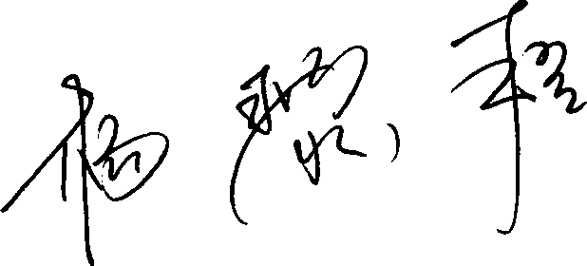
CONTAINER CLEANLINESS STATEMENT (for FCL/X consignments only - statement to be removed from document when not relevant)

The container(s) covered by this document has/have been cleaned and is/are free from material of animal and/or plant origin and soil.

Signed: ................................. ........................... Printed name:. Yang Lichen
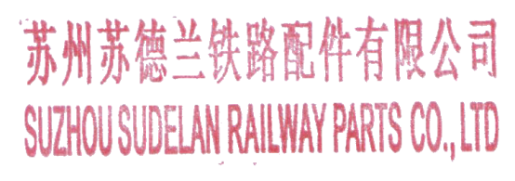
(Company representative)

Date of issue:....... 29/4/2024.................
(DD/MM/YYYY)

